Squeeze announce From The Cradle To The Grave Tour, plus first album of new material for 17 years and a starring role in a new TV comedy for their music

- The group will tour as a band for the first time in three years in the autumn - with special guest Dr John Cooper Clarke
- A new album, From The Cradle To The Grave, is due later this year
- The group’s songs will have a prominent role in new TV comedy Cradle To Grave

Tickets on general sale Friday 27th March 2015 at 10am
gigsandtours.com http://gigst.rs/Squeeze and ticketmaster.co.uk. By phone at 0844 811 0051 or 0844 826 2826.
London from £25.00 to £75.00. All others from £32.50 to £47.50

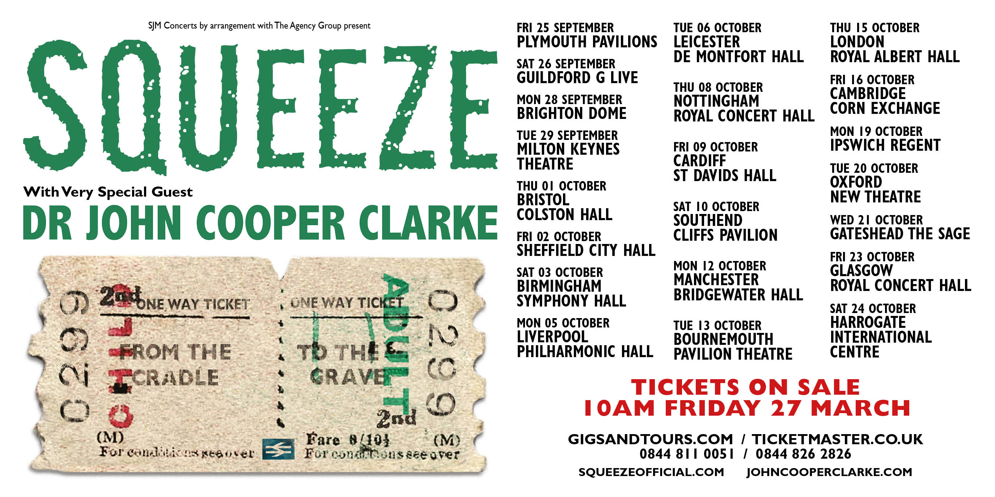

Squeeze, the enduring British pop act whose songs have tenderly and wittily chronicled life and love stretching across four decades, are to play an extensive UK tour in the autumn – their first, as a band, for three years. As well as a vast catalogue including hits such as Cools For Cats, Up The Junction and Tempted, it will include songs from forthcoming album From The Cradle To The Grave, which marks their first collection of new tracks since 1998.

The dates for the From The Cradle To The Grave Tour are:

Friday September 25 - Plymouth Pavilions
Saturday September 26 - Guildford G Live
Monday September 28 - Brighton Dome
Tuesday September 29 - Milton Keynes Theatre
Thursday October 01 - Bristol Colston Hall
Friday October 02 - Sheffield City Hall
Saturday October 03 - Birmingham Symphony Hall
Monday October 05 - Liverpool Philharmonic Hall
Tuesday October 06 - Leicester De Montfort Hall
Thursday October 08 - Nottingham Royal Concert Hall
Friday October 09 - Cardiff St David’s Hall
Saturday October 10 - Southend Cliffs Pavilion
Monday October 12 - Manchester Bridgewater Hall
Tuesday October 13 - Bournemouth Pavilion Theatre
Thursday October 15 - London Royal Albert Hall
Friday October 16 - Cambridge Corn Exchange
Monday October 19 - Ipswich Regent
Tuesday October 20 - Oxford New Theatre
Wednesday October 21 - Gateshead Sage 1
Friday October 23 - Glasgow Royal Concert Hall
Saturday October 24 - Harrogate International Centre

Squeeze have long been a captivating live act with an array of chart hits - which also includes the likes of Take Me I’m Yours, Slap And Tickle and Pulling Mussels (From The Shell) - but for this tour there is a further treat with new tracks which will appear on From The Cradle To The Grave. Some of the songs, including the title track, were taking shape as the band performed their Pop-Up Shop tour in 2012 and later this year they will be the basis for their first album of all-new material since Domino in 1998. Squeeze’s last studio release, Spot The Difference in 2010, saw them reworking many of their best known hits dating back to the early days of their career, in order to give them more creative control over their catalogue.

The group first formed in 1974, shortly after Chris Difford and Glenn Tilbrook had begun their songwriting partnership, brought together by an ad in a sweetshop window. By 1977 they had made their recording debut and enjoyed a string of hits which lasted until 1982, the maturity of their songs outliving their initial burst of chart activity on the back of New Wave. Over the years there have been solo careers and occasional separations, but the Ivor Novello Award-winning songwriting duo Chris and Glenn got back together eight years ago to relaunch Squeeze.

Glenn says: “We split in 1998 after the release of Domino. Chris and I were not getting on so well, we needed a break and to follow our own paths for a bit. We slowly but surely came back together as people, and then reformed Squeeze in 2007. Originally, this was only planned as a short reunion, but things went so well, here we are eight years later. Four years ago we agreed that if we were to carry on, we really needed to work on new material.”

Chris says of their fresh songs: “We’ve grown up a lot in the last few years, musically. For the first five years back together, we were saying ‘this is where we came from’. Now, this is where we are. We still love and own our past, but as musicians we needed to grow.”

Many of the new songs will feature in a forthcoming TV comedy series Cradle To Grave, providing the backdrop for the episodes which are based on the life of their old friend Danny Baker, the writer and broadcaster. The eight-part run, set in the 1970s, is an adaptation of Danny’s autobiography Going To Sea In a Sieve and he has co-written the programmes with award-winning scriptwriter and producer/director Jeff Pope.

It will star comedian Peter Kay as Danny’s father Fred and Lucy Speed as the presenter’s mother Bet. NME writer turned TV presenter and DJ Danny was brought up in Deptford, the old stomping ground of the band, and Squeeze were asked to become involved at an early stage.

Glenn recalls: “When I read the book, I got in contact with Danny and said that I thought we could do something together with his book. Danny was already talking with Jeff Pope about a TV series and the mood and sentiment of Cradle were completely in sync. Danny and Jeff both loved it and everything else followed on from there.”

When the team behind the show heard From The Cradle To The Grave, they were so impressed that it was used as the inspiration for the name of the show. Chris, who also manages young rock act The Strypes, says: “The scripts were inspiring; hugely funny. It tapped into a period that lyrically I was very familiar with as I grew up in the same neighbourhood as Danny.
”We have been on location to see how it is going. It gave us a spring in our step to see the quality of filming and the direction and the attention to detail. It was very heartening and we are grateful to be involved in something that is so refreshing and also represents our past – we went to the same school, wore the same uniform, fell in love with same art teacher!
Chris had been a huge fan of Danny’s eclectic musical tastes, as showcased on his radio shows which have seen him on the airwaves at Radio 1, Radio 2 and BBC London 94.9. But he muses: "I didn't really have much to do with him when he was at NME. It’s really only the last five or 10 years really. He came to my 50th birthday party and we remembered where we had both come from.”

Chris and Glenn hit the road as a duo to great acclaim in 2014, strengthening further their once fragile bond, but the dates this autumn mark their first tour, since their Pop-up Shop shows in 2012, as Squeeze with the rest of the group.

Support on the tour will come from poet and punk godfather Dr John Cooper Clarke, the bard of Salford. John shot to fame in the 1970s for his quickfire delivery of dry, biting and hilarious satirical verse, touring with the likes of The Clash and Sex Pistols. The tousled, raven-haired creator of (I Married A) Monster From Outer Space, Evidently Chickentown and Beasley Street has gone on to collaborate with Arctic Monkeys and been a panellist on BBC1’s Have I Got News For You. He recently recorded a new version of 1960s hit MacArthur Park with Hugh Cornwell and Jethro Tull’s Ian Anderson.
See www.squeezeofficial.com @SqueezeOfficial / SqueezeOfficial for more details about the band and tour.

For more information, contact Republic Media info@republicmedia.net 020 3213 0135

